**University of Engineering and Technology, Taxila**

**Department of Computer Engineering**

**Mobile Application And Development**

**PORTFILIO WEBSITE**

**Project**

**Submitted by:**

Maryum

19-CP-55

**Submitted to:**

Sir Zahid

**PERSONAL PORTFILIO WEBSITE:**

This is my personal portfolio website as I am a freelance user interface designer. I designed my 10 pages portfolio website.

It includes all my skills, my experience, projects, and my education details. I designed this using

* HTML
* CSS
* JQUERY
* JAVASCRIPT LIBRARIES

LINK:

https://maryum-portfilio.netlify.app/project.html

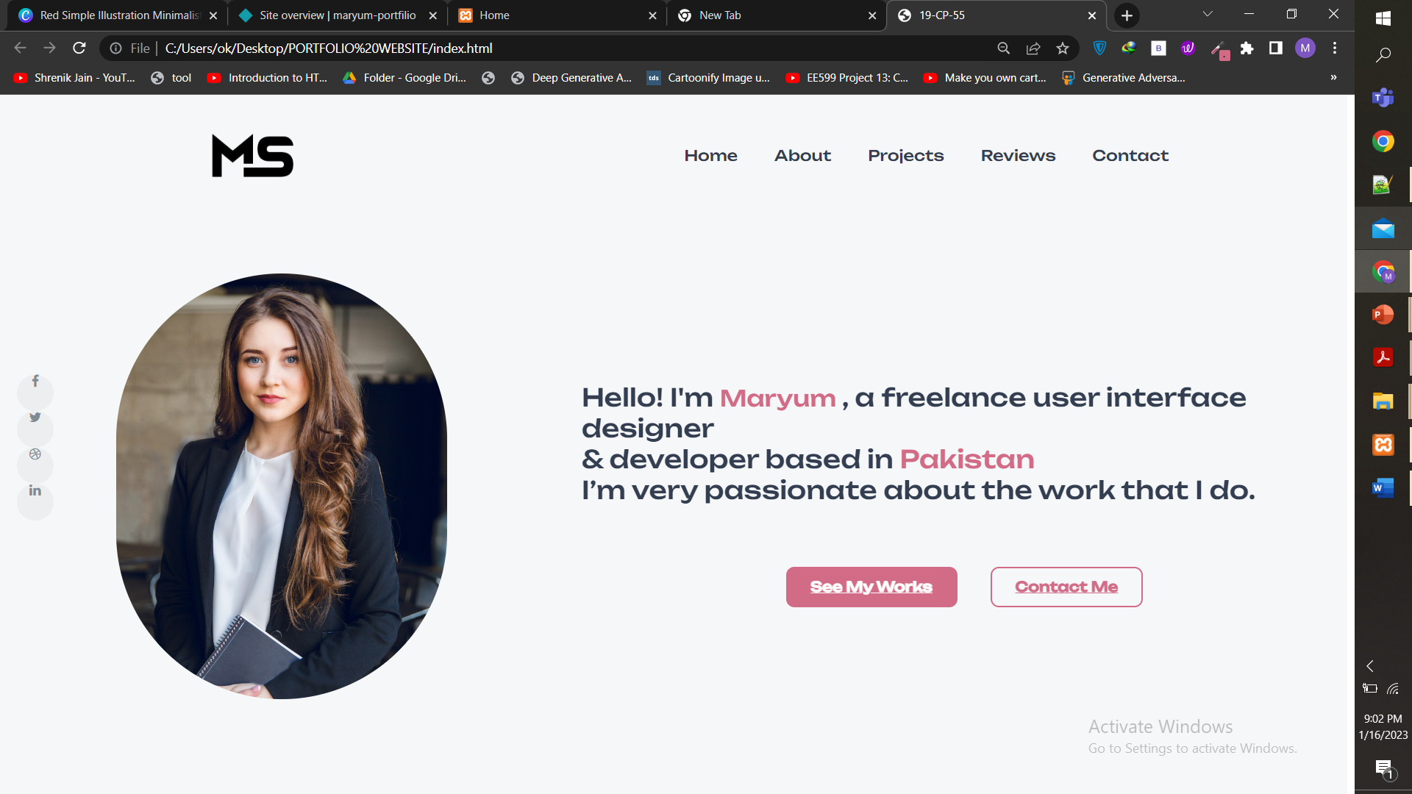

**CODE:**

<html lang ="en">

<head>

<meta charset ="UTF-8" >

<meta name="viewport" content="width=device-width, initial-scale=1.0">

<meta http-equiv = "X-UA-Compatible" content = "ie=edge">

<title>19-CP-55</title>

<link rel="shortcut icon" href="logo.jpg">

<link rel="stylesheet" href="style.css">

<script src="https://unpkg.com/scrollreveal"></script>

<link rel="stylesheet" href="https://stackpath.bootstrapcdn.com/font-awesome/4.7.0/css/font-awesome.min.css">

<script src= "https://kit.fontawesome.com/c4254e24a8.js" crossorigin="anonymous"></script> <script src="scripttt.js"></script>

</head>

<body>

<div id= "header">

<div class= "container">

<nav>

<a href="index.html"><img src="logo.png" style="width:220px;" >

<ul>

<li><a href="index.html">Home</a></li>

<li><a href="about.html">About</a></li>

<li><a href="project.html">Projects</a></li>

<li><a href="reviews.html">Reviews</a></li>

<li><a href="contact.html">Contact</a></li>

</ul>

</nav></div></div>

<div >

<ul class="social-icons" style="position:absolute;display:flex;flex-flow:column wrap;top:40%;padding-left:20px">

<li><a class="facebook" href="#"><i class="fa fa-facebook"></i></a></li>

<li><a class="twitter" href="#"><i class="fa fa-twitter"></i></a></li>

<li><a class="dribbble" href="#"><i class="fa fa-dribbble"></i></a></li>

<li><a class="linkedin" href="#"><i class="fa fa-linkedin"></i></a></li>

</ul>

</div>

</div>

<section class="1" style="background-color:#F6F7F9">

<div style="margin-top:70px;padding-left:140px"> <img src ="logoo.jpg" width="400px"h style="border-radius:200px"> </div>

<div class="header-text" style="margin-left: 10%;margin-top:200px;">

<p class="text">

Hello! I'm <span style="font-size:27px;color:hsla(344, 53%, 62%, 1);"> Maryum </span>, a freelance user interface designer <br>& developer based in <span style="font-size:30px;color:hsla(344, 53%, 62%, 1);"> Pakistan </span><br>I’m very passionate

about the work that I do.

</p>

<br><br><div class="btn-wrapper">

<a href="project.html" class="btn btn-primary">See My Works</a>

<a href="contact.html" class="btn btn-secondary">Contact Me</a>

</div>

</div>

</section>

<section class="2">

<div id= "about">

<div class= "row">

<div class= "about-col-1">

<img src= "4.gif" width="480" style="margin-left:60px;margin-top:160px">

</div></div>

<div class= "about-col-2" style="margin-left:80px;margin-top:160px">

<h1 class="sub-title">About Me</h1>

<p>

<br> I'm passionate about improving the lives of others through design and

<br> am constantly looking to learn new things everyday..</p>

<div class="tab-titles">

<a href="skills.html" class="tab-links">Skills</a>

<a href="#" class="tab-links">Experience</a>

<a href="education.html" class="tab-links">Education</a>

</div>

<div class="btn-wrapper">

<a href="about.html" class = "btn btn-secondary" ><b>Learn More</b></a>

<a href="cv.pdf" class = "btn btn-secondary" ><b>Download CV</b></a></div>

</div>

</div>

</section>

<section class="3"style="background:#D6DCE7">

<div class="container111">

<div><h1 style="font-size:40px;color:hsl(219, 22%, 26%);font-family: 'Unbounded';">MY SERVICES</h1></div>

<div class="card">

<div class="face face1">

<div class="content">

<i class="fa fa-windows"></i>

<h3>Web Design</h3>

</div>

</div>

<div class="face face2">

<div class="content">

<p> Web design encompasses many different skills and disciplines in the production and maintenance of websites.</p>

<a href="web design.html" type="button">Read More</a>

</div>

</div>

</div>

<div class="card">

<div class="face face1">

<div class="content">

<i class="fa fa-mobile"></i>

<h3>App Design</h3>

</div>

</div>

<div class="face face2">

<div class="content">

<p> Mobile app design examples. Designers have a hard time using the right set of materials to design their screens with. </p>

<a href="app design.html" type="button">Read More</a>

</div>

</div>

</div>

<div class="card">

<div class="face face1">

<div class="content">

<i class="fa fa-link"></i>

<h3>Prototyping</h3>

</div>

</div>

<div class="face face2">

<div class="content">

<p>Prototyping is an experimental process where design teams implement ideas into tangible forms from paper to digital.</p>

<a href="prototyping.html" type="button">Read More</a>

</div>

</div>

</div>

</section>

<br><br><br><br><br><Br><br>

</body>

<footer class="site-footer" >

<div>

<h2 style="font-size:30px;text-align:center;color:hsl(219, 22%, 26%)">Let's connect</h2>

<p style="font-size:30px;text-align:center;color:hsl(219, 22%, 26%)">Get in touch for opportunities or just to say hi! 👋</p>

<br>

<div style="text-align:center;">

<ul class="social-icons">

<li><a class="facebook" href="#"><i class="fa fa-facebook"></i></a></li>

<li><a class="twitter" href="#"><i class="fa fa-twitter"></i></a></li>

<li><a class="dribbble" href="#"><i class="fa fa-dribbble"></i></a></li>

<li><a class="linkedin" href="#"><i class="fa fa-linkedin"></i></a></li>

</ul>

</div>

</div>

</footer>

<div class="loader">

<img src="1.gif" alt="">

</div>

<script src="scripttt.js"></script>

<script>

ScrollReveal({reset:true,distance:'20px',delay:200});

ScrollReveal().reveal('.text', { delay: 300 });

ScrollReveal().reveal('p', { delay: 500 });

ScrollReveal().reveal('.tab-titles', { delay: 500 });

ScrollReveal().reveal('.sub-title', { delay: 500 });

ScrollReveal().reveal('h1', { delay: 500 });

ScrollReveal().reveal('.btn-wrapper', { delay: 500 });

</script>

</html>

CODE:

<section class="section about" >

<div class="container">

<div class="wrapper" style="font-size:20px;text-align:center;margin-left:3%;font-family: 'Unbounded';">

<div data-reveal="left">

<h2 class="h2 section-title" style="color:#343e51" >What I Do?</h2>

<br><Br>

<p class="section-text" style="color:#343e51">

Create a visually stunning and intuitive interface for users of websites, applications, or even games.Design all the screens that make up a digital user interface, <br>as well as the individual elements featured on those screens. As such, they consider both the overall layout of each individual screen and how all the separate screens fit together.

<br>

</div>

<div class="row">

<div class="carousel" data-flickity='{ "freeScroll": true }'>

<div class="carousel-cell" style="background-color:#C7B1DD;;text-align:center">

<a href = "web design.html"<p class="card-tag" style="text-align:center; font-weight:800;font-size:30px;color:#343e51">Web Design</p> </a>

<BR>

<p class="card-text"style="text-align:center;color:#343e51">

Web design refers to the design of websites that are displayed on the internet.

</p>

<BR>

<figure class="card-banner" >

<img src="web.gif" width="560" height="280">

</figure>

</div>

<div class="carousel-cell" style="background-color: #B0D4C1;text-align:center" >

<a href = "app design.html" <p class=" card-tag" style="text-align:center; font-weight:800;font-size:30px;color:#343e51">Mobile Design</p> </a>

<BR>

<p class="card-text" style="text-align:center;color:#343e51">

User Interface Development” is the development of websites, web applications,

<figure class="card-banner" >

<img src="app.gif" width="560" height="280">

</figure>

</div>

<div class="carousel-cell" style="background-color:#E3A6B6;text-align:center">

<p class=" card-tag" style="text-align:center; font-weight:800;font-size:30px;color:#343e51">SEO</p>

<br>

<br>

<p class="card-text">

Search engine optimization is the process of improving the quality and quantity of website traffic to

<br> a website or a web page from search engines.

</p>

<br>

</section>

<BR><BR><BR><BR>

<script>

ScrollReveal({reset:true,distance:'30px',delay:300});

ScrollReveal().reveal('.header-text');

ScrollReveal().reveal('.wrapper', { delay: 300 });

ScrollReveal().reveal('section-text', { delay: 500 });

ScrollReveal().reveal('p', { delay: 500 });

;</script>

</body>

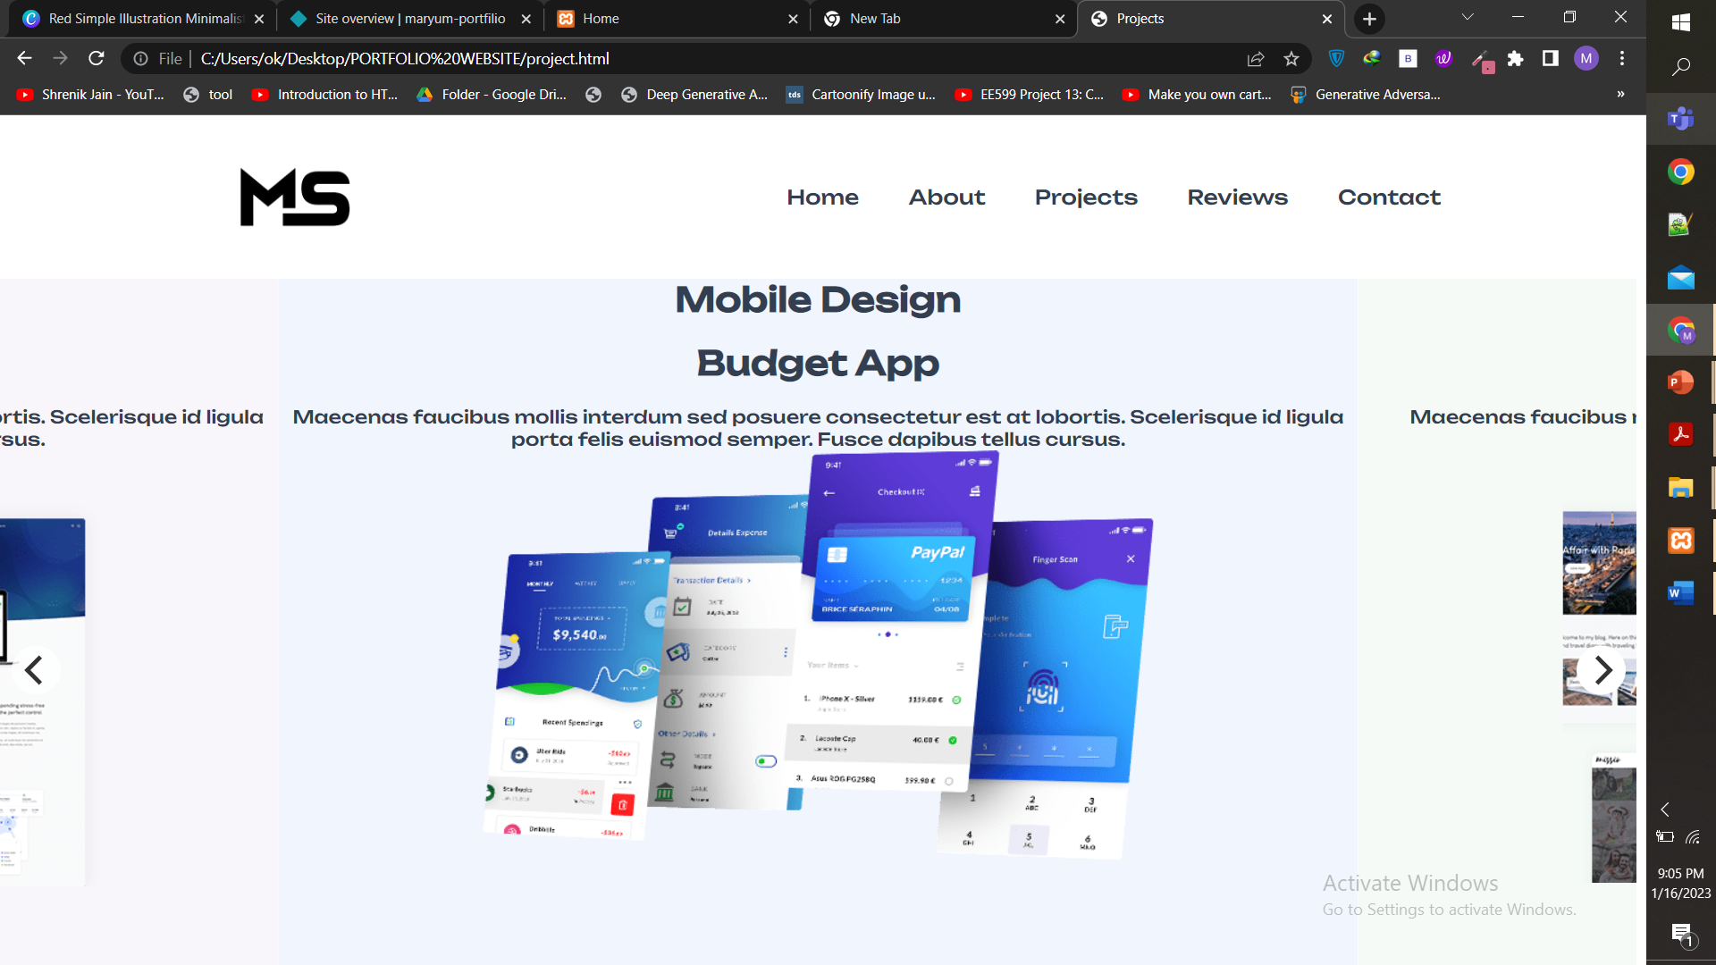

**CODE:**

**<section class="section project" >**

**<div class="carousel" data-flickity='{ "freeScroll": true }'>**

**<div class="carousel-cell" style="background-color: #f8f5fb;text-align:center">**

**<p class="card-tag" style="text-align:center; font-weight:800;font-size:30px;color:#343e51">Web Design</p>**

**<BR>**

**<h3 class="h3 card-title" style="text-align:center; font-weight:800;font-size:30px;color:#343e51">Snowlake Theme</h3>**

**<BR>**

**<p class="card-text"style="text-align:center;color:#343e51">**

**Maecenas faucibus mollis interdum sed posuere consectetur est at lobortis. Scelerisque id ligula**

**porta felis euismod semper. Fusce dapibus tellus cursus.**

**</p>**

**<BR>**

**<figure class="card-banner" >**

**<img src="project-1.png" width="650" height="370"**

**>**

**</figure>**

**</div>**

**<div class="carousel-cell" style="background-color: #f1f5fd;text-align:center" >**

**<p class=" card-tag" style="text-align:center; font-weight:800;font-size:30px;color:#343e51">Mobile Design</p>**

**<BR> <h3 class="h3 card-title" style="text-align:center; font-weight:800;font-size:30px;color:#343e51">Budget App</h3>**

**<BR>**

**<p class="card-text" style="text-align:center;color:#343e51">**

**Maecenas faucibus mollis interdum sed posuere consectetur est at lobortis. Scelerisque id ligula**

**porta felis euismod semper. Fusce dapibus tellus cursus.**

**</p>**

**<figure class="card-banner" >**

**<img src="project-2.png" width="600" height="367">**

**</figure>**

**<div class="carousel-cell" style="background-color: #f5faf7;text-align:center">**

**<p class=" card-tag" style="text-align:center; font-weight:800;font-size:30px;color:#343e51">Web Design</p>**

**<br>**

**<h3 class="h3 card-title" style="text-align:center; font-weight:800;font-size:30px;color:#343e51">Mission Theme</h3>**

**<br>**

**<p class="card-text">**

**Maecenas faucibus mollis interdum sed posuere porta consectetur cursus porta lobortis. Scelerisque**

**id ligula felis.**

**</p>**

**<br>**

**figure class="card-banner" >**

**<img src="project-3.png" width="600" height="367" l>**

**<div class="carousel-cell"style="background-color: #fcf4f6;text-align:center">**

**<p class=" card-tag" style="text-align:center; font-weight:800;font-size:30px;color:#343e51">Mobile Design</p>**

**<br>**

**<h3 class="h3 card-title" style="text-align:center; font-weight:800;font-size:30px;color:#343e51">Storage App</h3>**

**<br>**

**<p class="card-text">**

**Maecenas faucibus mollis interdum sed posuere consectetur est at lobortis. Scelerisque id ligula**

**porta felis euismod semper.**

**</p>**

**<br><br><br>**

**<figure class="card-banner" >**

**<img src="project-4.png" width="620" height="370"**

**>**

**</figure>**

**</div>**

**</section>**

**CODE:**

**</nav></head>**

**<body>**

**<div style="background-image:url('re.gif');background-position:cover;background-repeat:no-repeat;background-position:center;">**

**<span class="heading">User Rating</span>**

**<span class="fa fa-star checked"></span>**

**<span class="fa fa-star checked"></span>**

**<span class="fa fa-star checked"></span>**

**<span class="fa fa-star checked"></span>**

**<span class="fa fa-star"></span><br>**

**<p>4.1 average based on 254 reviews.</p><br>**

**<hr>**

**<br>**

**<div class="row" >**

**<div class="side">**

**<div>5 star</div>**

**</div>**

**<div class="middle">**

**<div class="bar-container">**

**<div class="bar-5"></div>**

**</div>**

**</div>**

**<div class="side right">**

**<div>150</div>**

**</div><br><br>**

**<div class="side">**

**<div>4 star</div>**

**</div>**

**<div class="middle">**

**<div class="bar-container">**

**<div class="bar-4"></div>**

**</div>**

**</div>**

**<div class="side right">**

**<div>63</div>**

**</div><br><br>**

**<div class="side">**

**<div>3 star</div>**

**</div>**

**<div class="middle">**

**<div class="bar-container">**

**<div class="bar-3"></div>**

**</div>**

**</div>**

**<div class="side right">**

**<div>15</div>**

**</div><br><br>**

**<div class="side">**

**<div>2 star</div>**

**</div>**

**<div class="middle">**

**<div class="bar-container">**

**<div class="bar-2"></div>**

**</div>**

**</div>**

**<div class="side right">**

**<div>6</div>**

**</div><br><br>**

**<div class="side">**

**<div>1 star</div>**

**</div>**

**<div class="middle">**

**<div class="bar-container">**

**<div class="bar-1"></div>**

**</div>**

**</div>**

**<div class="side right">**

**<div>20</div>**

**</div>**

**</div>**

**<br><br><br>**

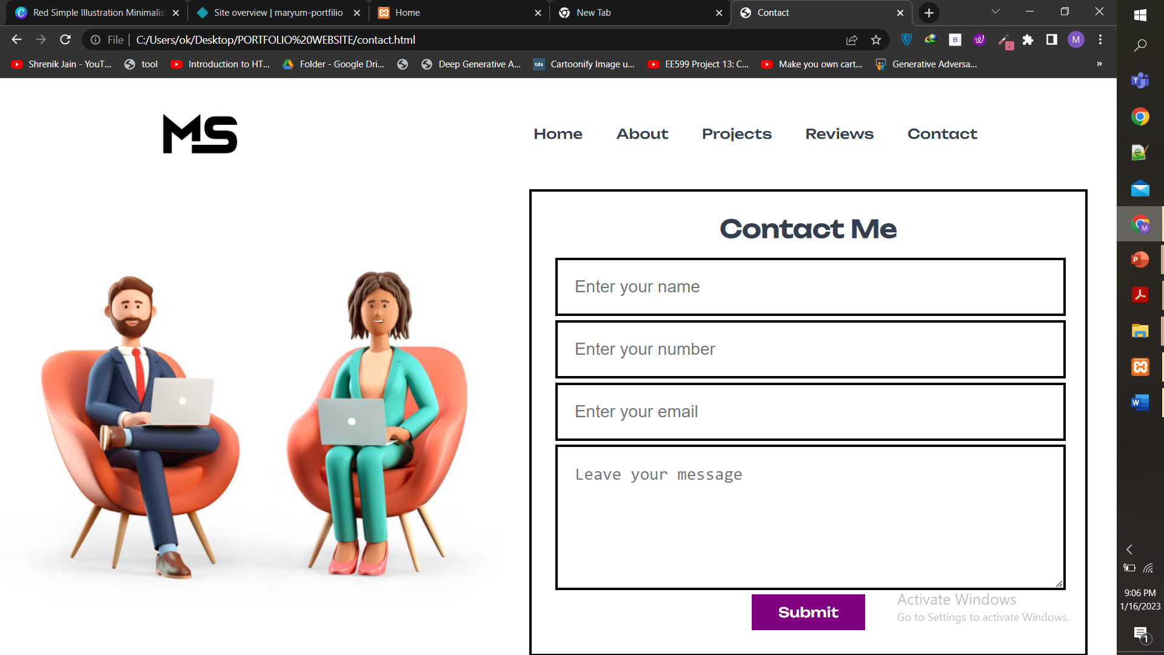

**CODE:**

**<section class="contact">**

**<div class="row">**

**<div class="image">**

**<img src="2.jpg" alt="">**

**</div>**

**<form action="" method="post">**

**<h3>Contact Me</h3>**

**<input type="text" name="name" required placeholder="Enter your name" maxlength="50" class="box">**

**<input type="number" name="number" required placeholder="Enter your number" max="9999999999" min="0" class="box" onkeypress="if(this.value.length == 10) return false;">**

**<input type="email" name="email" required placeholder="Enter your email" maxlength="50" class="box">**

**<textarea name="msg" placeholder="Leave your message" required class="box" cols="30" rows="10" maxlength="500"></textarea>**

**<input type="submit" value="Submit" class="ctn" name="send">**

**</form>**

**</div>**

**</section>**

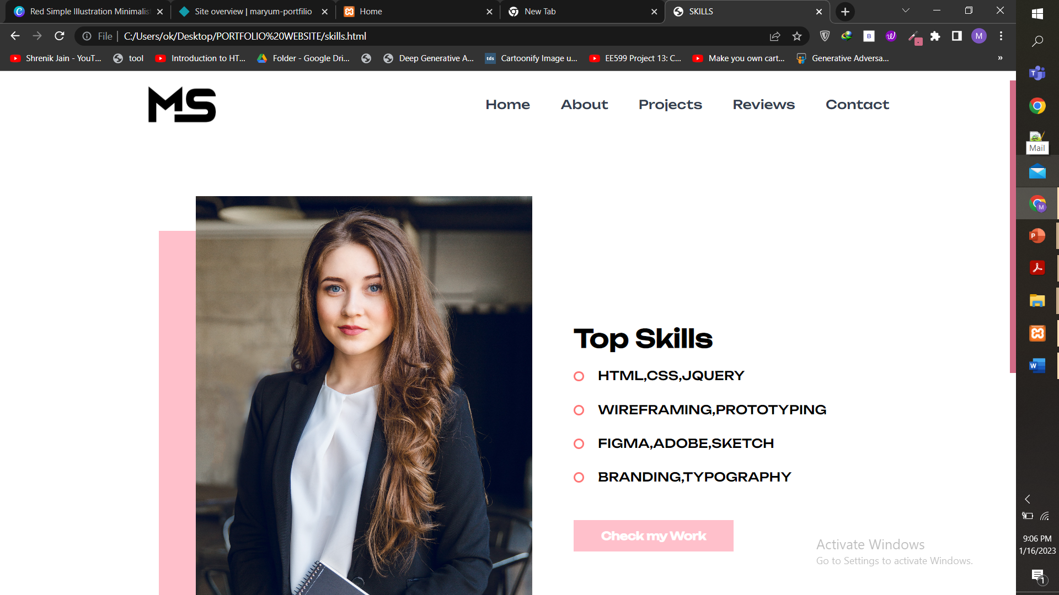

**CODE:**

**<div class="new_skills" Style="margin-left:80px">**

**<div class="new_skills" Style="margin-left:120px">**

**<div class="responsive-container-block bigContainer">**

**<div class="responsive-container-block Container">**

**<div class="responsive-container-block imgContainer">**

**<div class="pinkBG">**

**</div>**

**<img class="bigImg" src="logoo.jpg">**

**</div>**

**<div class="responsive-container-block textContainer">**

**<p class="text-blk heading">**

**Top Skills**

**</p>**

**<div class="textRow">**

**<div class="bullet">**

**</div>**

**<p class="text-blk bulletText">**

**HTML,CSS,JQUERY**

**</p>**

**</div>**

**<div class="textRow">**

**<div class="bullet">**

**</div>**

**<p class="text-blk bulletText">**

**WIREFRAMING,PROTOTYPING**

**</p>**

**</div>**

**<div class="textRow">**

**<div class="bullet">**

**</div>**

**<p class="text-blk bulletText">**

**FIGMA,ADOBE,SKETCH**

**</p>**

**</div>**

**<div class="textRow last">**

**<div class="bullet">**

**</div>**

**<p class="text-blk bulletText">**

**BRANDING,TYPOGRAPHY**

**</p>**

**</div>**

**<a href ="project.html" <a class="viewMore">**

**Check my Work**

**</section>**

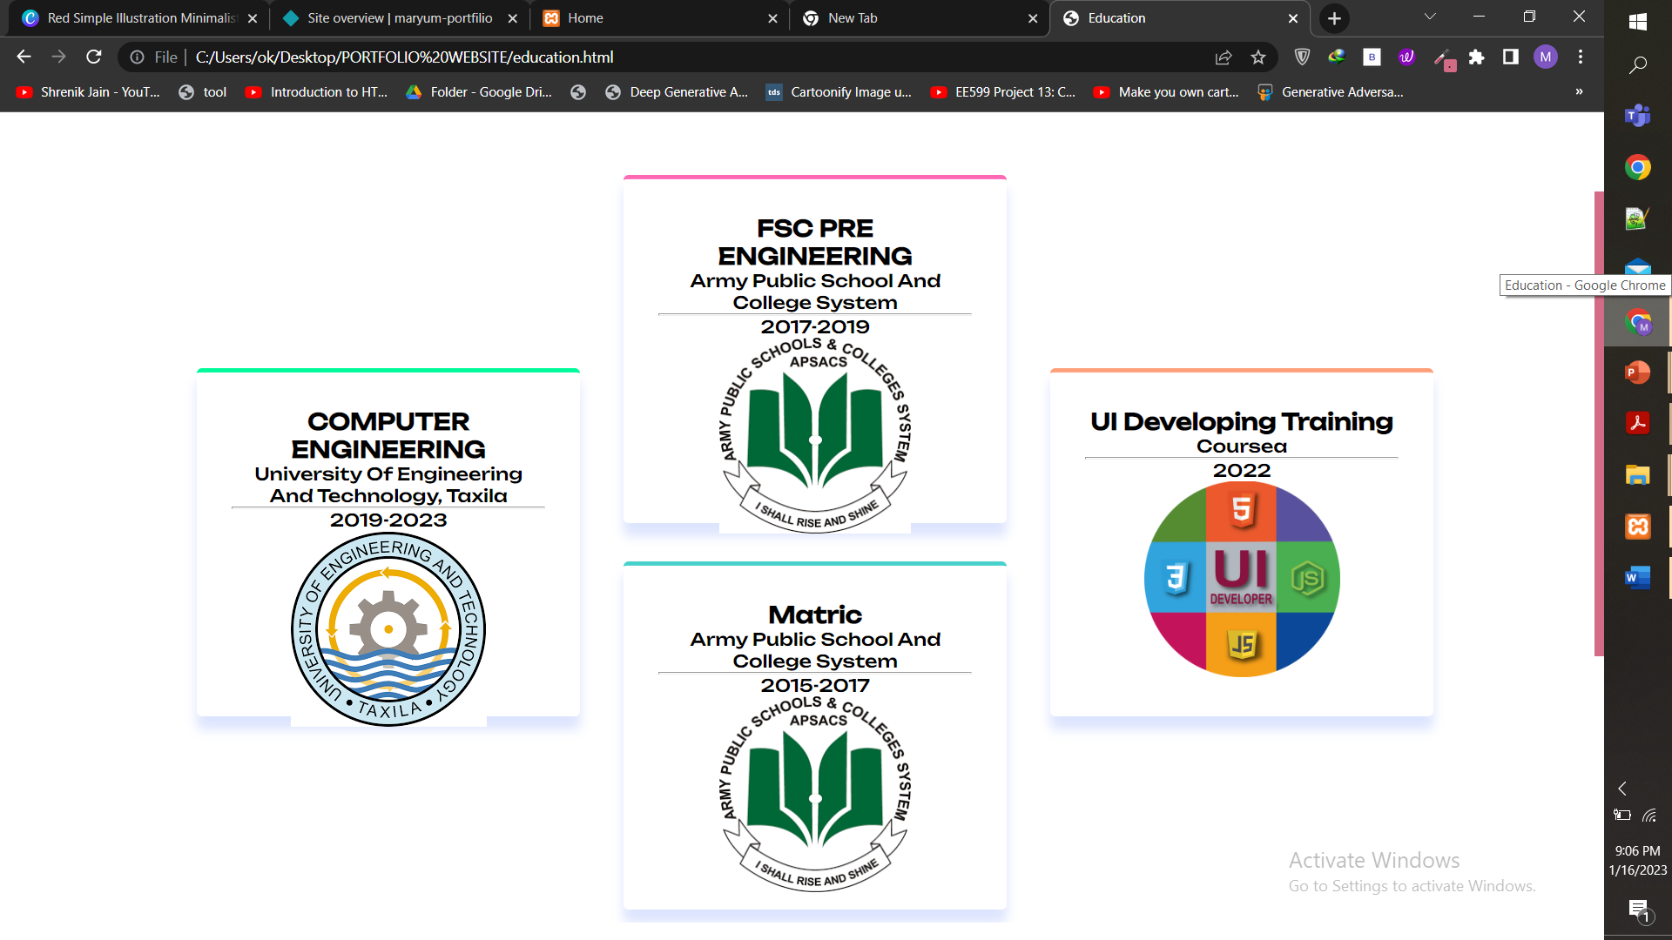

**CODE:**

**<section class="feature_wrapper">**

**<div class="first_column columns">**

**<div class="features first_box">**

**<h3>COMPUTER ENGINEERING</h3><p>University Of Engineering And Technology, Taxila**

**<hr>2019-2023</p>**

**<img src="eed.png" height="180px">**

**</div>**

**</div>**

**<div class="second_column columns">**

**<div class="features second_box">**

**<h3>FSC PRE ENGINEERING</h3><p>Army Public School And College System <hr> 2017-2019</p> <img src="eed1.png" height="180px">**

**</div>**

**<div class="features third_box">**

**<h3>Matric</h3><p>Army Public School And College System <hr> 2015-2017</p> <img src="eed1.png" height="180px">**

**</div>**

**</div>**

**<div class="third_column columns">**

**<div class="features last_box">**

**<h3>UI Developing Training</h3><p>Coursea <hr>2022</p> <img src="eed2.png" height="180px">**

**</div>**

**</div>**

**</section>**

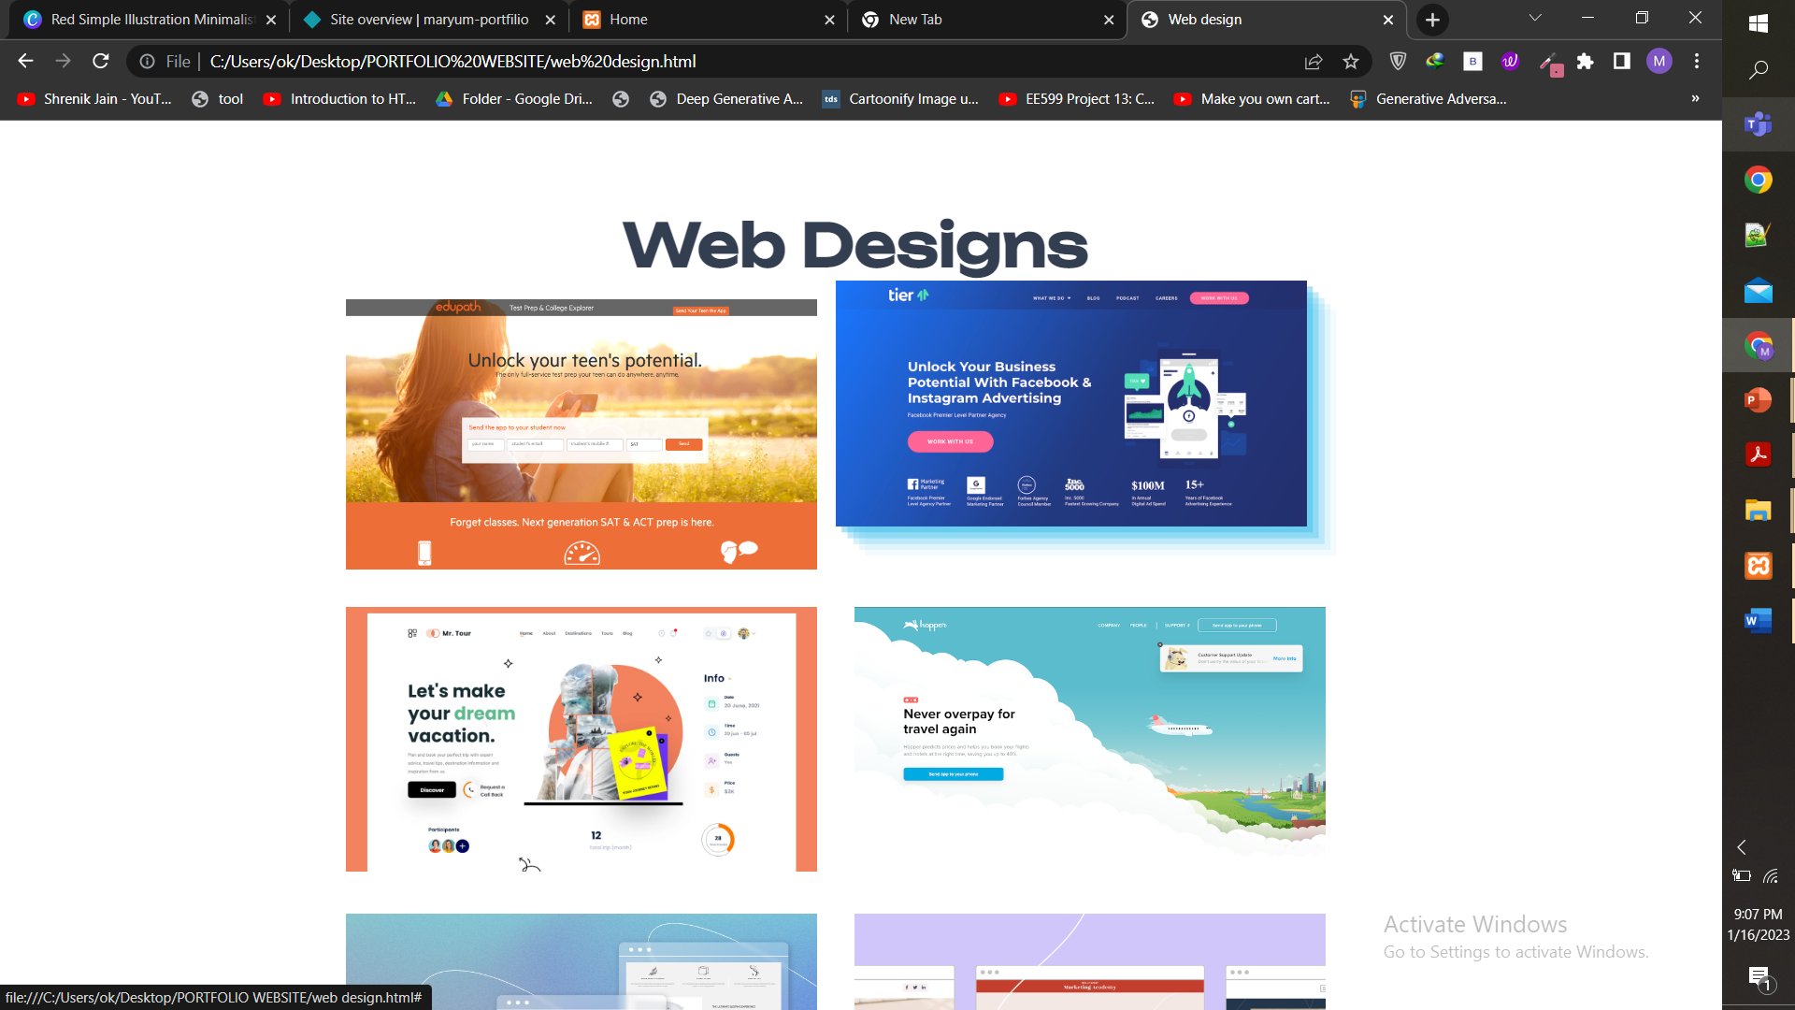

**CODE:**

<section style="padding:30px">

<div>

<div>

<h1 style="color:#343E51;font-size:50px;font-weight:700;text-align:center;font-family: 'Unbounded';"> Web Designs </h1>

<div class="grid image-grid">

<div class="grid-block">

<div class="tile">

<a class="tile-link" href="#">

<img class="tile-img tile-img1" src="web2.png">

</a>

</div>

</div>

<div class="grid-block">

<div class="tile">

<a class="tile-link" href="#">

<img class="tile-img tile-img2" src="web3.png">

</a>

</div>

</div>

<div class="grid-block">

<div class="tile">

<a class="tile-link" href="#">

<img class="tile-img tile-img3" src="web4.jpg">

</a>

</div>

</div>

<div class="grid-block">

<div class="tile">

<a class="tile-link" href="#">

<img class="tile-img tile-img4" src="web5.png">

</a>

</div>

</div>

<div class="grid-block">

<div class="tile">

<a class="tile-link" href="#">

<img class="tile-img tile-img5" src="web6.jpeg">

</a>

</div>

</div>

<div class="grid-block">

<div class="tile">

<a class="tile-link" href="#">

<img class="tile-img tile-img6" src="web7.jpg">

</a>

</div>

</div>

<div class="grid-block">

<div class="tile">

<a class="tile-link" href="#">

<img class="tile-img tile-img7" src="web7.png">

</a>

</div>

</div>

<div class="grid-block">

<div class="tile">

<a class="tile-link" href="#">

<img class="tile-img tile-img8" src="web8.png">

</a>

</div>

</div>

</div>

**</section>**

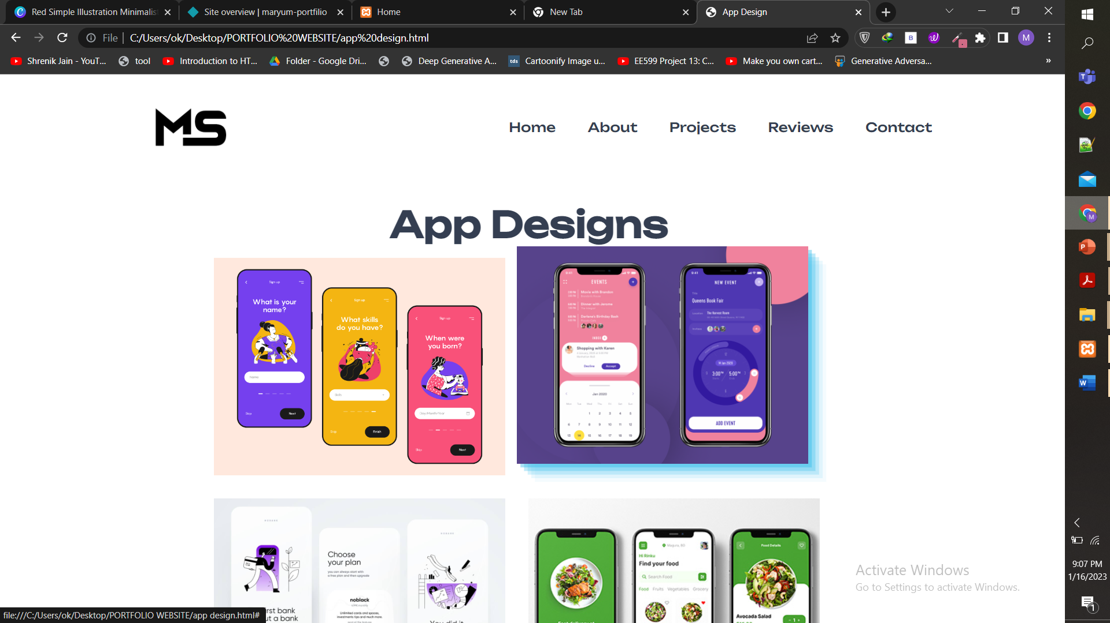

**CODE:**

**<section style="padding:30px">**

**<div>**

**<div>**

**<h1 style="color:#343E51;font-size:50px;font-weight:700;text-align:center;font-family: 'Unbounded';"> App Designs </h1>**

**<div class="grid image-grid" >**

**<div class="grid-block">**

**<div class="tile">**

**<a class="tile-link" href="#">**

**<img class="tile-img tile-img1" src="app1.png">**

**</a>**

**</div>**

**</div>**

**<div class="grid-block">**

**<div class="tile">**

**<a class="tile-link" href="#">**

**<img class="tile-img tile-img2" src="app5.png">**

**</a>**

**</div>**

**</div>**

**<div class="grid-block">**

**<div class="tile">**

**<a class="tile-link" href="#">**

**<img class="tile-img tile-img3" src="app3.jpg">**

**</a>**

**</div>**

**</div>**

**<div class="grid-block">**

**<div class="tile">**

**<a class="tile-link" href="#">**

**<img class="tile-img tile-img4" src="app4.jpg">**

**</a>**

**</div>**

**</div>**

**<div class="grid-block">**

**<div class="tile">**

**<a class="tile-link" href="#">**

**<img class="tile-img tile-img5" src="app2.png">**

**</a>**

**</div>**

**</div>**

**<div class="grid-block">**

**<div class="tile">**

**<a class="tile-link" href="#">**

**<img class="tile-img tile-img6" src="app6.png">**

**</a>**

**</div>**

**</div>**

**<div class="grid-block">**

**<div class="tile">**

**<a class="tile-link" href="#">**

**<img class="tile-img tile-img7" src="app7.png">**

**</a>**

**</div>**

**</div>**

**<div class="grid-block">**

**<div class="tile">**

**<a class="tile-link" href="#">**

**<img class="tile-img tile-img8" src="app8.png">**

**</a>**

**</div>**

**</div>**

**<div class="grid-block">**

**<div class="tile">**

**<a class="tile-link" href="#">**

**<img class="tile-img tile-img9" src="app9.jpg">**

**</a>**

**</div>**

**</div>**

**<div class="grid-block">**

**<div class="tile">**

**<a class="tile-link" href="#">**

**<img class="tile-img tile-img10" src="app10.png">**

**</a>**

**</div>**

**</div>**

**</div>**

**</section><br><br><br>**

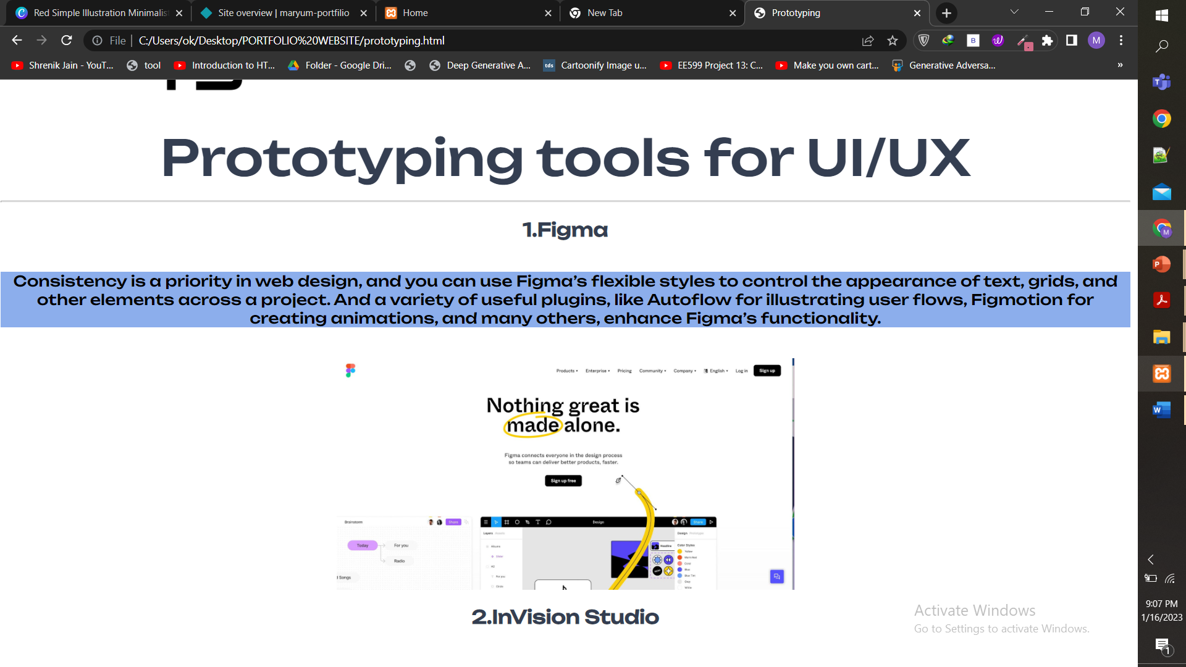

**CODE:**

**<section>**

**<h1 style="color:#343e51">Prototyping tools for UI/UX </h1><hr><br>**

**<h2 style="color:#343e51">1.Figma</h2><br><br>**

**<p style="background-color:#8CAEEC;">Consistency is a priority in web design, and you can use Figma’s flexible styles to control the appearance of text, grids, and other elements across a project. And a variety of useful plugins, like Autoflow for illustrating user flows, Figmotion for creating animations, and many others, enhance Figma’s functionality.</p><br><br>**

**<img src="figma.jpeg" height="300px"> <br><br>**

**<h2 style="color:#343e51">2.InVision Studio</h2><br><br>**

**<p style="background-color:#8CAEEC;">With a host of well-designed tools, InVision gives designers the power to put together functional prototypes quickly and to share them with others. It offers so many nice features, including a handy vector drawing tool, repeatable components that can be changed sitewide, and tools for creating animations and other dynamic visual effects.</p><br><br>**

**<img src="invasion.jpeg" height="300px"><br><br>**

**<h2 style="color:#343e51">3.Adobe XD</h2><br><br>**

**<p style="background-color:#8CAEEC;">Adobe XD offers a vector-based system for putting together prototypes, including tools for creating interactions, transitions, and other types of dynamic functionality. Because it’s vector based, scaling and resizing elements is no problem.</p><br><br>**

**<img src="ad.jpeg" height="300px"> <br><br>**

**<h2 style="color:#343e51">4.Webflow</h2><br><br>**

**<p style="background-color:#8CAEEC;">Webflow takes care of two jobs at once. While you’re designing and building a high-fidelity prototype, you’re creating a live website that’s complete with all of the HTML, CSS, and associated JavaScript. You don’t end up with just a mockup — you’ll have the real deal.</p><br><br>**

**<img src="ad1.jpeg" height="300px"> <br><br>**

**</section>**

**STYLESHEET:**

**\*{**

**margin: 0;**

**padding:0;**

**box-sizing: border-box;}**

**@font-face {font-family: 'Unbounded';**

**src: url('font.ttf');**

**}**

**::-webkit-scrollbar{width:10px;}**

**::-webkit-scrollbar-track{background:white;}**

**::-webkit-scrollbar-thumb{background:white;}::-webkit-scrollbar-thumb:hover{background:#D16B86;}**

**section{min-height: 100vh;**

**display: flex;**

**}**

**.loader{**

**position: fixed;**

**top:0; left:0; right:0; bottom: 0;**

**background-color: white;**

**z-index: 10000;**

**display: flex;**

**align-items: center;**

**justify-content: center;**

**}**

**.loader img{**

**width: 35rem;**

**}**

**img {border-radius:22px}**

**#header{**

**background-color:#F6F7F9;font-family: 'Unbounded';**

**}**

**#11{font-family: 'Unbounded';}**

**nav{**

**display: flex;**

**align-items: center;**

**justify-content: space-around;font-family: 'Unbounded';**

**}**

**.logo{**

**width: 140px;**

**}**

**nav ul li{**

**display: inline-block;**

**list-style: none;**

**margin: 10px 20px;**

**}**

**nav ul li a{**

**color: #343e51;**

**text-decoration: none;**

**font-size: 18px;**

**position: relative;**

**}**

**nav ul li a::after{**

**content: '';**

**height: 4px;**

**background: purple;**

**position: absolute;**

**left: 0;**

**bottom:-6px; I**

**transition:0.5s;**

**}**

**nav ul li a:hover::after{**

**width: 100%;font-family: 'Unbounded';}**

**.header-text{**

**margin-top: 10%;**

**margin-left:10%;**

**font-size: 30px;**

**color:#343e51;font-family: 'Unbounded';**

**}**

**.header-text h1{**

**font-size: 60px;**

**margin-top: 20px;font-family: 'Unbounded';**

**}**

**.header-text h1 span{**

**color: purple;font-family: 'Unbounded';}**

**#about{**

**font-family: 'Unbounded'; display: flex; width:100%;**

**}**

**.about-col-1 img{**

**border-radius: 15px;**

**}**

**.sub-title{**

**font-size: 80px;**

**font-weight: 600;**

**color: #343e51;font-family: 'Unbounded';**

**}**

**.tab-titles{**

**display: flex;**

**margin: 20px 0 40px;font-family: 'Unbounded';}**

**.tab-links{**

**margin-right: 50px;**

**font-size: 20px;**

**font-weight: 900;**

**cursor: pointer;**

**position: relative;**

**text-decoration:none;font-family: 'Unbounded';}**

**.ctn{**

**display: inline-block;**

**text-decoration: none;**

**color: #343e51;**

**border: 3px solid white;**

**padding: 12px 34px;**

**font-size: 18px;**

**background: transparent;**

**position: relative;**

**cursor: pointer;**

**}**

**.ctn:hover{**

**border: 1px solid purple;**

**background: purple;**

**transition:1s;}**

**.column {**

**float: left;**

**width: 25%;**

**padding: 10px;**

**height: 350px;**

**text-align:center;**

**font-family: 'Unbounded';**

**}**

**.container111{**

**display: flex;**

**justify-content: center;**

**font-family: 'Unbounded';**

**margin-top:120px;**

**padding:60px**

**}**

**.container111 .card .face{**

**width:300px;**

**height: 200px;**

**font-family: 'Unbounded';**

**text-align:center;**

**transition:.4s;**

**}**

**.container111 .card .face.face1{**

**position: relative;**

**background:grey;**

**display: flex;**

**justify-content: center;**

**font-family: 'Unbounded';**

**align-items: center;**

**z-index: 1;**

**transform: translateY(100px);**

**}**

**.container111 .card:hover .face.face1{**

**transform: translateY(0);**

**box-shadow:**

**inset 0 0 60px whitesmoke,**

**inset 20px 0 80px #f0f,**

**inset -20px 0 80px #0ff,**

**inset 20px 0 300px #f0f,**

**inset -20px 0 300px #0ff,**

**0 0 50px #fff,**

**-10px 0 80px #f0f,**

**10px 0 80px #0ff;**

**}**

**.container111 .card .face.face1 .content{**

**opacity: .5;**

**transition: 0.5s;**

**text-align: center;font-family: 'Unbounded';**

**}**

**.container111 .card:hover .face.face1 .content{**

**opacity: 5;**

**}**

**.container111 .card .face.face1 .content i{**

**font-size: 43;**

**color: white;**

**}**

**.container111 .card .face.face1 .content h3{**

**font-size: 20;**

**color: white;**

**text-align: center;**

**}**

**.container111 .card .face.face1 .content a{**

**transition: .5s;**

**}**

**.container111 .card .face.face2{**

**position: relative;font-family: 'Unbounded';**

**background: whitesmoke;**

**display: flex;**

**align-items: center;**

**justify-content: center;**

**padding: 20px;**

**box-sizing: border-box;**

**box-shadow: 0 20px 50px rgba(0,0,0,.8);**

**transform: translateY(-100px);**

**}**

**.container111 .card:hover .face.face2{**

**transform: translateY(0);**

**}**

**.container111 .card .face.face2 .content p, a{**

**font-size: 10pt;**

**color:#333;**

**}**

**.container111 .card .face.face2 .content a{**

**text-decoration:none;**

**color: black;**

**box-sizing: border-box;**

**outline : 1px dashed #333;**

**padding: 10px;**

**margin: 15px 0 0;**

**display: inline-block;font-family: 'Unbounded';**

**}**

**.container111 .card .face.face2 .content a:hover{**

**background: #333 ;**

**color: whitesmoke;**

**box-shadow: inset 0px 0px 10px rgba(0,0,0,0.5);**

**}**

**.btn-wrapper {**

**display: flex;**

**justify-content: center;**

**align-items: center;**

**gap: 40px;font-family: 'Unbounded';**

**}**

**.btn {**

**color:hsla(344, 53%, 62%, 1);**

**font-size: 17;**

**font-weight:700;**

**border: 2px solid hsla(344, 53%, 62%, 1);**

**padding: 12px 28px;**

**border-radius: 10px;**

**transition: 1s;font-family: 'Unbounded';**

**}**

**.btn-primary,**

**.btn-secondary:is(:hover, :focus-visible) {**

**background-color: hsla(344, 53%, 62%, 1);**

**color: white;font-family: 'Unbounded';**

**}**

**.services-list{**

**display: flex;**

**grid-gap:30px;**

**margin-top: 20px;**

**width:50%;font-family: 'Unbounded';**

**}**

**.services-list div{**

**padding: 20px;**

**font-size: 13px;**

**font-weight: 300;**

**border-right: 10px;font-family: 'Unbounded';**

**}**

**.site-footer**

**{**

**width:100%;**

**height: 400px;font-family: 'Unbounded';**

**background-image: url("ft.png");**

**background-size: cover;**

**background-position: center;**

**}**

**.social-icons li**

**{**

**display:inline-block;**

**}**

**.social-icons a{**

**background-color:#eceeef;**

**color:#818a91;**

**font-size:16px;**

**display:inline-block;**

**line-height:44px;**

**width:45px;**

**height:44px;**

**text-align:center;**

**margin-right:8px;**

**border-radius:100%;**

**-webkit-transition:all .2s linear;**

**-o-transition:all .2s linear;**

**transition:all .2s linear**

**}**

**.social-icons a:active,.social-icons a:focus,.social-icons a:hover**

**{**

**color:#343e51;**

**background-color:#29aafe;**

**}**

**.social-icons a.facebook:hover**

**{**

**background-color:#3b5998**

**}**

**.social-icons a.twitter:hover**

**{**

**background-color:#00aced**

**}**

**.social-icons a.linkedin:hover**

**{**

**background-color:#007bb6**

**}**

**.social-icons a.dribbble:hover**

**{**

**background-color:#ea4c89**

**}**

**.wrapper {**

**display: grid;**

**gap: 50px;**

**margin-block-end: 70px;**

**}**

**.progress-list .label-wrapper {**

**display: flex;**

**justify-content: space-between;**

**align-items: center;**

**margin-block-end: 4px;**

**}**

**.progress {**

**background-color: black;**

**height: 6px;**

**width: 97%;**

**border-radius: 12px;**

**overflow: hidden;**

**}**

**.progress-fill { height: inherit; }**

**.about-card { text-align: center;**

**}**

**.about-card .card-icon {**

**max-width: max-content;**

**margin-inline: auto;**

**}**

**.about-card .card-title { margin-block: 16px 10px; }**

**.project { border-block: 1px solid hsla(222, 23%, 71%, 0.2); }**

**.project .title-wrapper { margin-block-end: 40px; }**

**.project .btn { margin-block-start: 24px; }**

**.project .grid-list { gap: 40px; }**

**.project-card {**

**padding: 24px;**

**display: flex;**

**flex-direction: column;**

**gap: 24px;**

**border-radius: 8px;**

**overflow: hidden;**

**}**

**.project-card-1,**

**.project-card-2,**

**:is(.project-card-3, .project-card-4) .card-content { padding: 24px; }**

**.project-card-1 { padding-block-end: 0; }**

**.project :is(.project-card-3, .project-card-4) { gap: 0; }**

**.project-card .card-tag {**

**font-size: 1.4rem;**

**font-weight: 700;**

**text-transform: uppercase;**

**}**

**.project-card .card-title { margin-block: 16px; }**

**.project-card .card-text { margin-block-end: 20px; }**

**.project-card .btn-text {**

**display: flex;**

**align-items: center;**

**gap: 5px;**

**font-weight:700;**

**transition:0.25s ease;**

**}**

**.project-card .btn-text:is(:hover, :focus-visible) { gap: 10px; }**

**SCRIPT:**

**function loader(){**

**document.querySelector('.loader').style.display = 'none';**

**}**

**function fadeOut(){**

**setInterval(loader, 2000);**

**}**

**window.onload = fadeOut;**

**const prev = document.querySelector(".prev");**

**const next = document.querySelector(".next");**

**function prevSlide(){**

**if (index == 0) {**

**index = slides.length - 1;**

**}**

**else{**

**index--;**

**}**

**changeSlide();**

**}**

**prev.addEventListener("click", function(){**

**prevSlide();**

**updateDotIndicator();**

**resetTimer();**

**})**

**next.addEventListener("click", function(){**

**nextSlide();**

**updateDotIndicator();**

**resetTimer();**

**})**

**function resetTimer(){**

**clearInterval(timer);**

**timer = setInterval(autoPlay, 5000);**

**}**

**const slides = document.querySelector(".slider-inner-container").children;**

**let index = 0;**

**function autoPlay(){**

**nextSlide();**

**updateDotIndicator();**

**}**

**function nextSlide(){**

**if (index == slides.length - 1) {**

**index = 0;**

**}**

**else{**

**index++;**

**}**

**changeSlide();**

**}**

**function changeSlide(){**

**for(let i=0; i < slides.length; i++){**

**slides[i].classList.remove("active");**

**}**

**slides[index].classList.add("active");**

**}**

**let timer = setInterval(autoPlay, 5000);**